Chapter 10, Solution 38.

Consider the circuit below.
I_{o}
j2 W
1 W
2 W
-j4 W
2Ð0° A
10Ð90° V
+
-
I₃
I₁
I₂
I₄
4Ð0° A
A

1 W
Clearly,
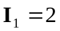 (1)
For mesh 2,
(2)

Substitute (1) into (2) to get
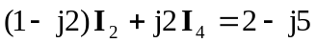

For the supermesh,
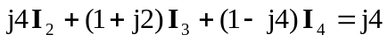 (3)
At node A,
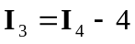 (4)
Substituting (4) into (3) gives
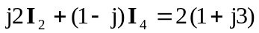 (5)
From (2) and (5),
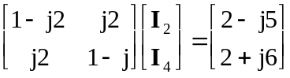

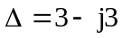, 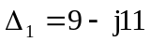

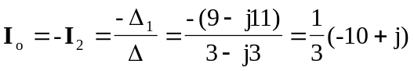
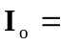 3.35Ð174.3° A

